Lab 7 – Building a Signup Form with Validation & Good UX
1. Objective
In this lab, students will design and implement a user registration (signup) form that collects user input, validates it, and provides clear feedback to the user.
The lab reinforces the key ideas from Module 7 – Forms & Validation, including:
- Using Form and TextFormField for structured input
- Using FormState and GlobalKey to validate and save data
- Applying built-in and custom validation rules
- Managing focus and keyboard behaviors on mobile devices
- Improving form UX with helpful error messages and button states
- (Optional) Adding asynchronous validation before creating an account
At the end, students will have a fully functional signup form that runs correctly in:
- DartPad (Flutter)
- Android Studio
- VS Code
2. Requirements
This lab is structured into four sub-tasks inside a single project:
- Lab 7.1 – Basic Registration Form (Form + TextFormField + Submit)
- Lab 7.2 – Validation Rules & Password Strength
- Lab 7.3 – Focus & Keyboard Management
- Lab 7.4 – Optional Async Validation (Email check)
You may complete these progressively in the same main.dart file (or keep separate branches/versions for each step).
2.1 Functional Requirements
Your signup screen must:
- Collect user information
  - Full name
  - Email
  - Password
  - Confirm password
- Validate user input
  - All fields are required
  - Email must have a valid format (@ and . at minimum)
  - Password must respect strength rules:
    - Minimum 8 characters
    - At least 1 digit
  - Confirm password must match password
- Provide UX feedback
  - Show inline error messages under invalid fields
  - Disable or block submission when form is invalid
  - Show a success message (e.g. SnackBar or dialog) when the form is valid
- (Optional – Async) Check email availability
  - Simulate an API check (using Future.delayed)
  - If the email looks “already taken” (e.g. starts with "taken"), show an error message
  - Disable the submit button while checking
2.2 Technical Requirements
- Use Flutter and Dart only (no third-party packages).
- The entire demo must run from a single file (e.g. main.dart), so it can be pasted into DartPad → New Flutter.
- Use Form, TextFormField, GlobalKey<FormState>, and the validator: pattern.
- Use autovalidateMode in at least one version of the form (AutovalidateMode.onUserInteraction is recommended).
- Use FocusNode and FocusScope to move focus between fields and to dismiss the keyboard.
- Wrap the main form content in ListView or SingleChildScrollView to avoid overflow when the keyboard is open.
- Code must compile and run without errors in:
  - DartPad (Flutter mode)
  - Android Studio
  - VS Code
2.3 Optional Enhancements (Bonus)
You may optionally:
- Add a Terms & Conditions checkbox that must be accepted before submission.
- Add a Show/Hide password icon button.
- Add simple password strength indicator (e.g. Weak / Medium / Strong).
- Add a loading indicator in the submit button when performing async validation.
- Add extra fields such as username, phone, or role.
These are not required for passing the lab but can improve your score.
3. Guided Steps
Step 1 – Project Setup
- Create a new Flutter project (e.g. flutter create lab7_forms_validation)
or open DartPad → New Flutter.
- Replace the default main.dart content with a minimal Flutter app that uses MaterialApp and a SignupScreen.
- Verify that the app runs with a simple “Hello” text before adding any form logic.
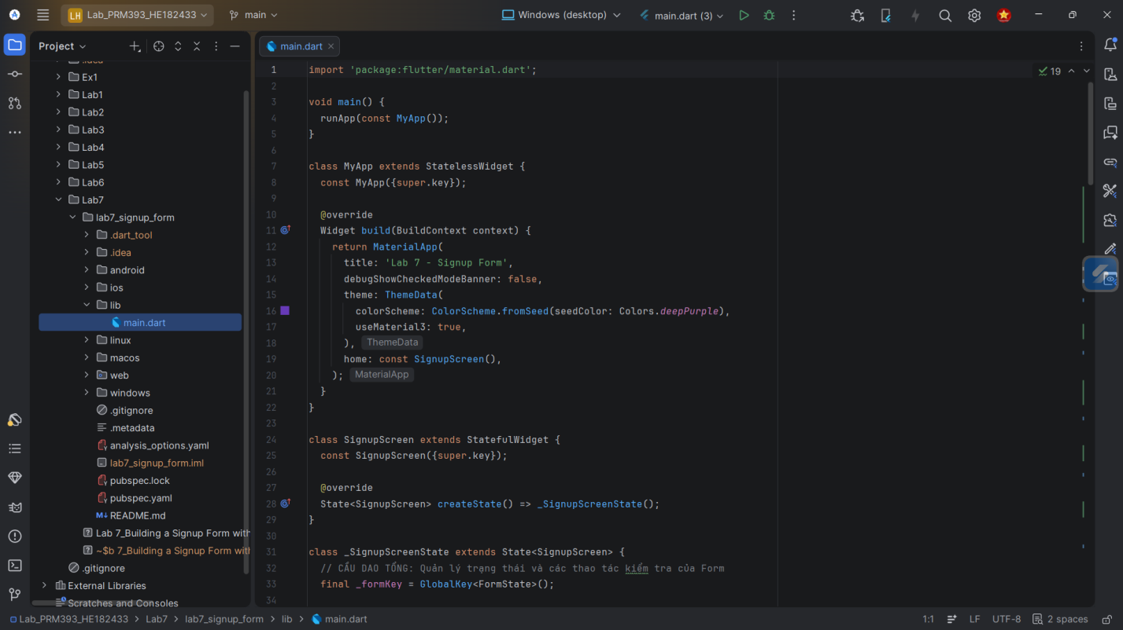
Step 2 – Create the Basic Form Layout (Lab 7.1)
- Inside SignupScreen, create a GlobalKey<FormState> named formKey.
- Wrap your content with a Form widget and assign key: formKey.
- Build the base layout:
  - Scaffold → AppBar(title: Text('Signup'))
  - body → Padding → Form → ListView (or SingleChildScrollView + Column)
- Add the following TextFormFields:
  - Full Name
  - Email
  - Password
  - Confirm Password
- Add a Submit button (e.g. ElevatedButton) below the fields.
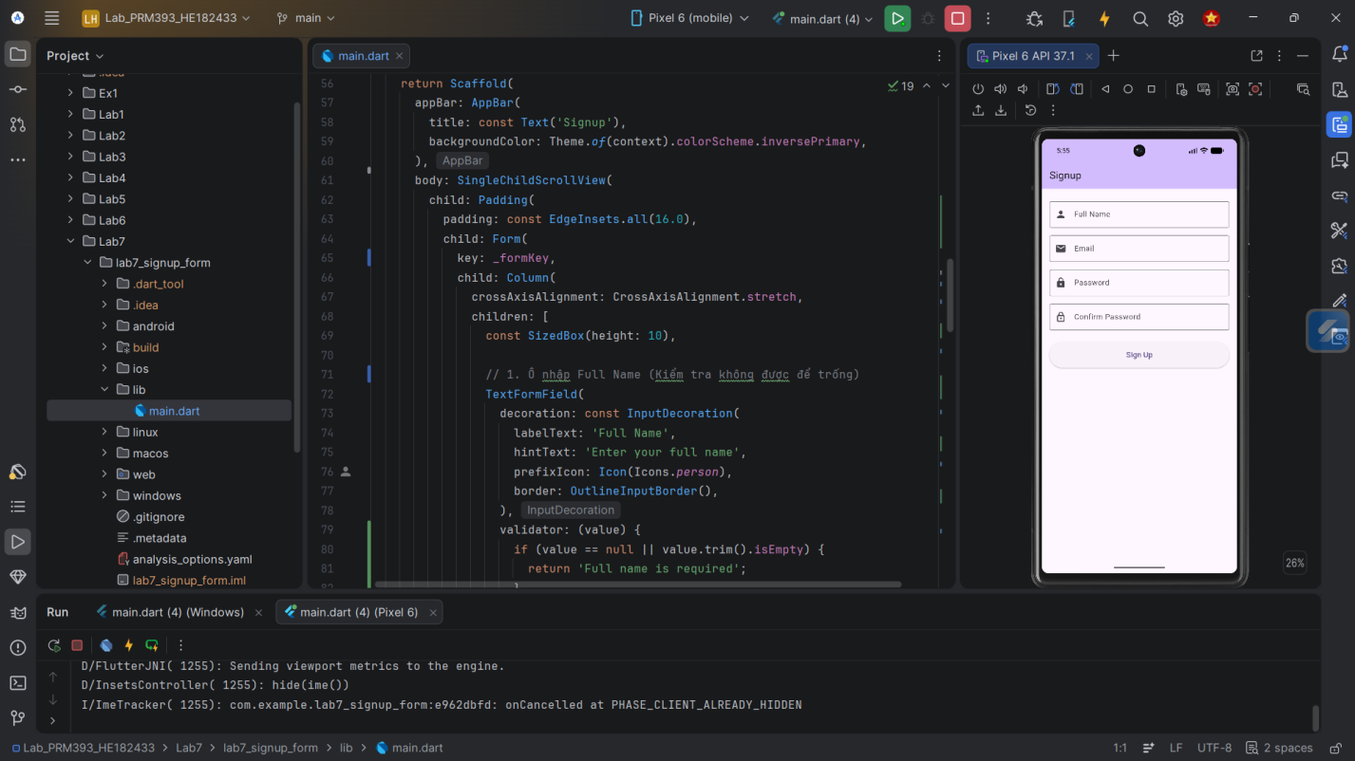
Goal: At this stage, the form may not have any validation logic – it just collects input.
Step 3 – Add Basic Validation (Required Fields & Email) (Lab 7.1 → 7.2)
- For each TextFormField, add a validator: function:
  - If the value is null or empty: return a short error message (e.g. "Name is required").
- For the email field:
  - Check if it contains at least @ and .
  - If invalid, return "Enter a valid email".
- In the onPressed of the Submit button:
  - Call final isValid = formKey.currentState!.validate();
  - If isValid is false, do nothing else.
  - If isValid is true, call formKey.currentState!.save(); and show a SnackBar confirming that the form is valid.
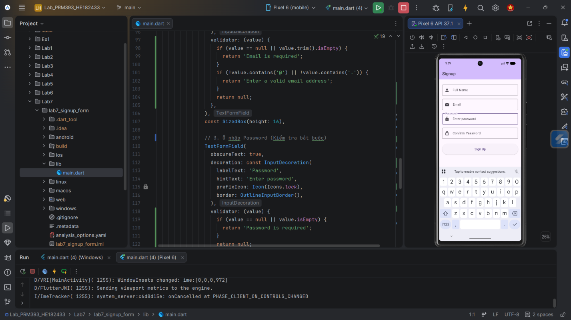
Goal: The form must not submit when required fields are empty or email is invalid.
Step 4 – Implement Password Rules & Confirm Password (Lab 7.2)
- Move validation logic into separate functions (e.g. String? validateEmail(String? value)), to keep code clean.
- For the password field:
  - Ensure at least 8 characters.
  - Ensure at least one digit (you can use RegExp(r'[0-9]')).
- For the confirm password field:
  - Compare with the password value stored in state (e.g. _password variable).
  - If they do not match, return "Passwords do not match".
- Enable autovalidateMode: AutovalidateMode.onUserInteraction on the Form to give quicker feedback as the user types.
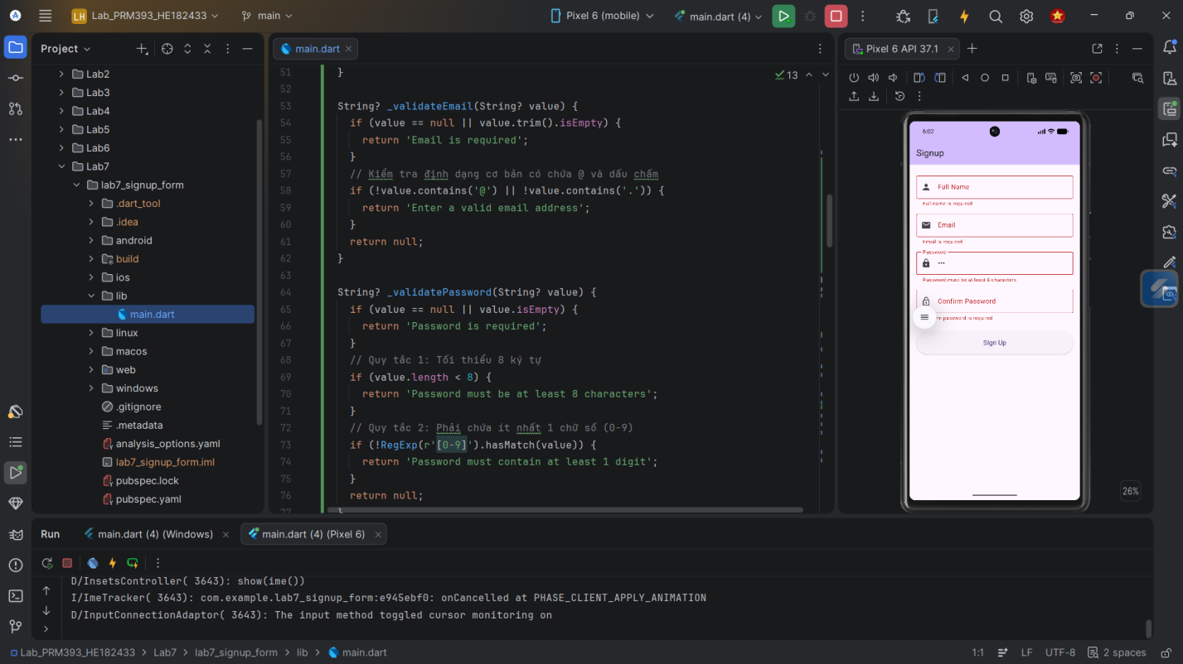
Goal: The form enforces stronger password rules and ensures confirmation matches.
Step 5 – Manage Focus & Keyboard (Lab 7.3)
- Create a FocusNode for each input field (name, email, password, confirm).
- Assign these FocusNodes to the corresponding TextFormFields.
- In textInputAction:
  - Set TextInputAction.next for all fields except the last one.
  - Set TextInputAction.done for the last field.
- Use onFieldSubmitted: to move focus:
  - From Name → Email
  - From Email → Password
  - From Password → Confirm
  - From Confirm → Call _submit() / validate
- Wrap the entire screen in a GestureDetector and in onTap, call FocusScope.of(context).unfocus() to dismiss the keyboard when tapping outside the form.
- Ensure the form is wrapped in ListView or SingleChildScrollView to avoid overflow when the keyboard is open.
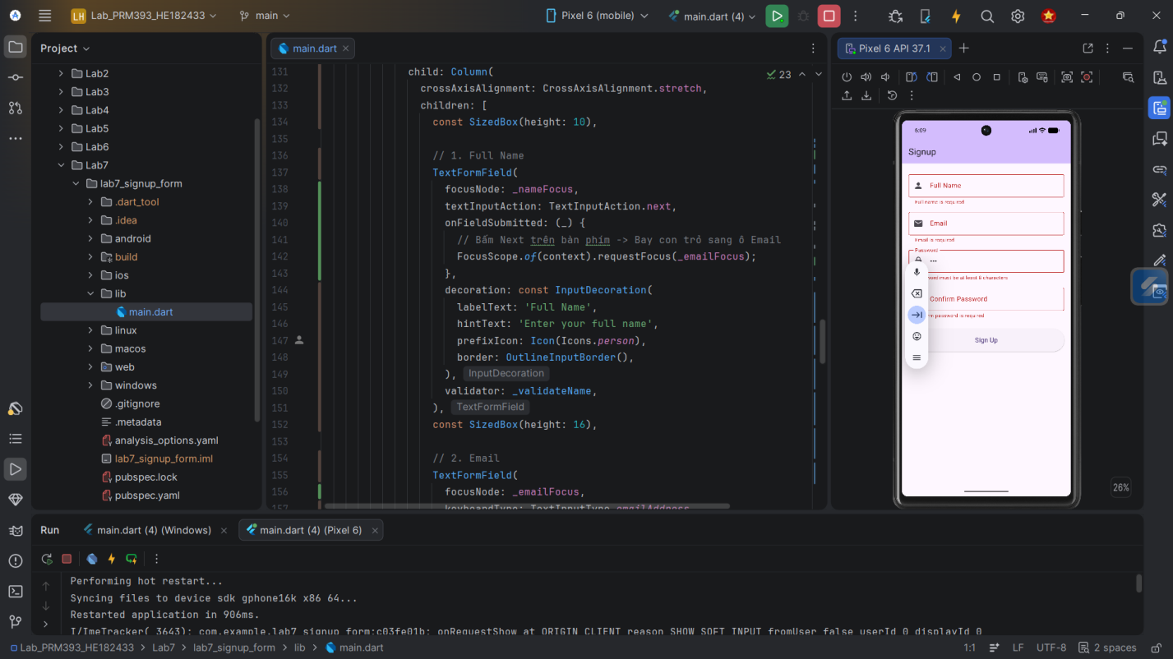
Goal: Users can move through fields smoothly with the keyboard and dismiss the keyboard easily.
Step 6 – Add Async Email Check (Optional, Lab 7.4)
- Add a boolean bool isCheckingEmail = false;.
- In your submit method:
  - First, run local validation:
if (!formKey.currentState!.validate()) return;
  - If valid, set isCheckingEmail = true and call setState.
- Simulate a server call:
  - await Future.delayed(const Duration(seconds: 2));
  - As a fake rule, treat emails starting with "taken" as already used.
- If the email is taken:
  - Show a SnackBar or dialog: "This email is already taken".
  - Do not proceed to success message.
- Regardless of the result, set isCheckingEmail = false and update the button:
  - While isCheckingEmail is true, disable the submit button and show a small CircularProgressIndicator instead of the text.
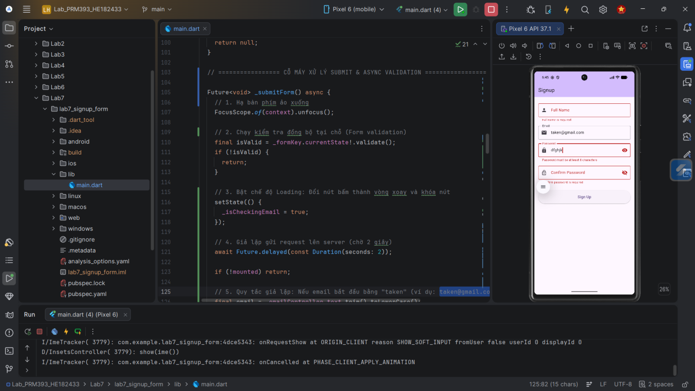
Goal: Demonstrate how to combine synchronous form validation with an asynchronous check before final submission.
4. Expected Result
When you finish the lab, your app should:
- Display a signup form with Full Name, Email, Password, and Confirm Password fields.
- Prevent submission when fields are empty or invalid.
- Show helpful error messages under each invalid field.
- Enforce password strength and ensure both password fields match.
- Allow users to navigate between fields using the Next/Done actions on the keyboard.
- Dismiss the keyboard when the user taps outside the fields.
- (Optional) Perform a fake asynchronous email check and show a message if the email is “already taken”.
- Run correctly in:
  - DartPad (Flutter mode)
  - Android Studio
  - VS Code
5. Submission
Deliverables:
- A zipped Flutter project or a DartPad Flutter share link containing the completed signup form.
- main.dart (or equivalent entry file) clearly showing:
  - Form structure
  - Validators
  - Focus/keyboard management
  - (Optional) async validation logic
- 2–3 screenshots of the app:
  - One with valid data and success message.
  - One with visible validation errors.
Evaluation Criteria:
- Form Structure & Flow (30%)
Correct use of Form, TextFormField, FormState, and submit flow.
- Validation Logic (30%)
Required fields, email format, password rules, confirm password, and error messages.
- UX & Interaction (25%)
Focus management, keyboard behavior, inline errors, button states, and overall usability.
- Code Quality & Clarity (15%)
Clean, readable code with meaningful names, separated validators, and minimal duplication.

